KLESociety's
KLETechnologicalUniversity



System Software Lab(23ECSE315)
Course Guide:Dr G S Hanchinmani

Open Ended Experiment Report on

“AVR Assembler For All Instruction”
SubmittedBy

Name | SRN | RollNo.
Yasaswi Kopparapu | 01FE21BCS242 | 241
Prabhat Kumar Rai | 01FE21BCS250 | 243
Vrashabh Kambalyal | 01FE21BCS231 | 240
Shahanshah Siddiqui | 01FE21BCS208 | 237

SubmittedTo

SCHOOLOFCOMPUTERSCIENCE&ENGINEERING,
KLETECHNOLOGICALUNIVERSITY
HUBLI–580 031(India).

Abstract:

A two-pass AVR assembler, capable of processing AVR assembly code, resolving symbols and generating corresponding object code. The first pass establishes symbol addresses and produces an intermediate file, while the second pass generates the final object program file. The assembler's flow involves symbol resolution, opcode and operand processing, and the conversion of assembly instructions into AVR-specific binary codes. Enhancements in code optimization, error handling, documentation, and comprehensive testing are recommended for further development.

Introduction:

System software is a category of software designed to manage and facilitate the operation of computer hardware. It includes operating systems, device drivers, utilities, and firmware, serving as an intermediary between application software and hardware.Key types of system software include operating systems, such as Windows or Linux, and utility software for tasks like disk management and antivirus protection.

Motivation:

The motivation for creating an AVR assembler for all instructions in both pass1 and
pass2 lies in the need for an efficient tool to convert assembly language programs
written for AVR microcontrollers into machine code. By implementing a two-pass
assembler, the conversion process is optimized, providing better error checking,
symbol resolution, and generation of object code. This facilitates the development
of embedded systems on AVR platforms, streamlining the programming workflow and ensuring accurate translation of assembly instructions into executable code for AVR microcontrollers.

ProblemStatement:

Develop an AVR assembler capable of processing assembly language programs for AVR microcontrollers, performing both pass1 and pass2 assembly, and generating
corresponding machine code. The assembler should handle all AVR instructions,

ensuring accuracy and efficiency in the translation process.

Objectives:

- Pass1 Processing:
- Tokenize the input assembly program.
- Generate a symbol table, recording addresses for labels.
- Handle directives like .ORG to set the program counter.
- Identify and handle invalid opcodes.

- Pass2 Processing:
- Generate object code for each assembly instruction.
- Resolve symbols and calculate addresses for jump and branch instructions.
- Handle addressing modes and encode instructions accordingly.
- Output the final machine code and assembly listing.

- Instruction Set Support:
- Implement support for the complete AVR instruction set.
- Handle data transfer, arithmetic, logical, control flow, and I/O instructions.
- Error Handling

- Rest of the report is organized as follows..

Data Structures (DS):

Symbol Table:
- A data structure to store symbols (labels) and their corresponding addresses during pass1.
Opcode Table:
- A table containing AVR instruction opcodes and their corresponding binary representations.
- Implemented as a hash table or an array for quick opcode retrieval during pass2.
Token Structure:
- A structure to represent tokens parsed from the input assembly code.
- Contains fields for label, opcode, and operands.

Algorithms:

Pass1 Algorithm:
- Tokenization of assembly code using string parsing techniques.
- Building the Symbol Table to record label addresses.

Pass2 Algorithm:

- Generating object code for each assembly instruction.
- Resolving symbols and calculating addresses for jump and branch instructions.
- Encoding instructions based on addressing modes.
- Producing the final machine code and assembly listing.

Error Handling Algorithms:

- Algorithms to detect and report errors such as invalid opcodes, undefined symbols, and syntax errors.
- Providing clear error messages to aid in debugging.

Testing and Verification Algorithm:
- Designing a testing suite with test cases covering various aspects of the assembler's functionality.
- Verifying the correctness of the assembler by comparing expected and actual output.

Compatibility Algorithm:
- Ensuring compatibility with various AVR microcontrollers by implementing architecture-specific handling.

Implementation:

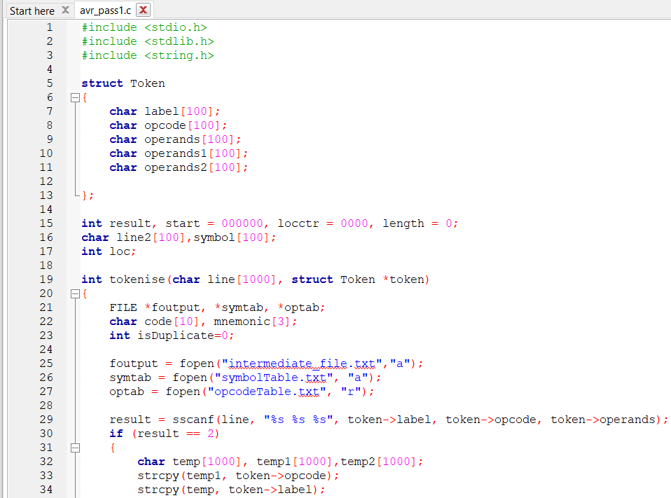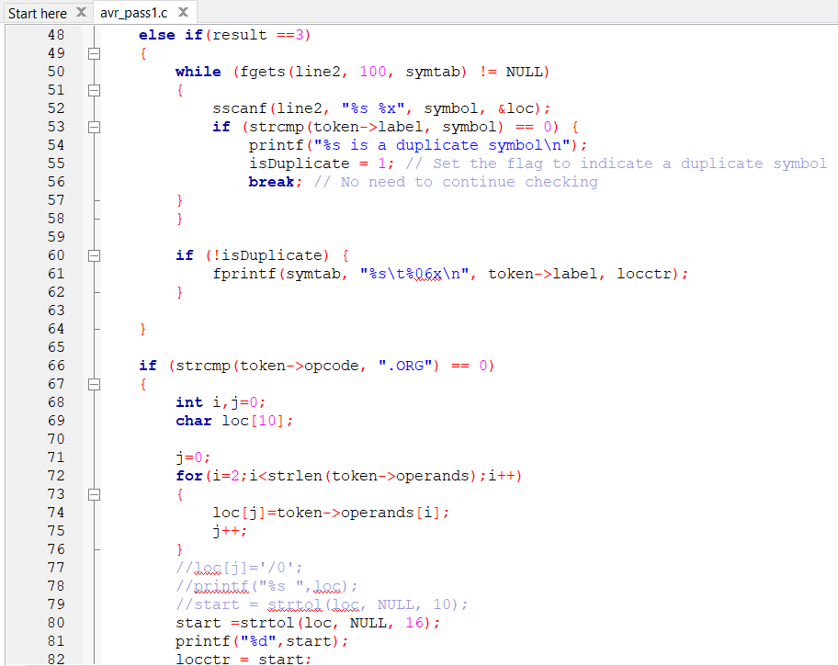

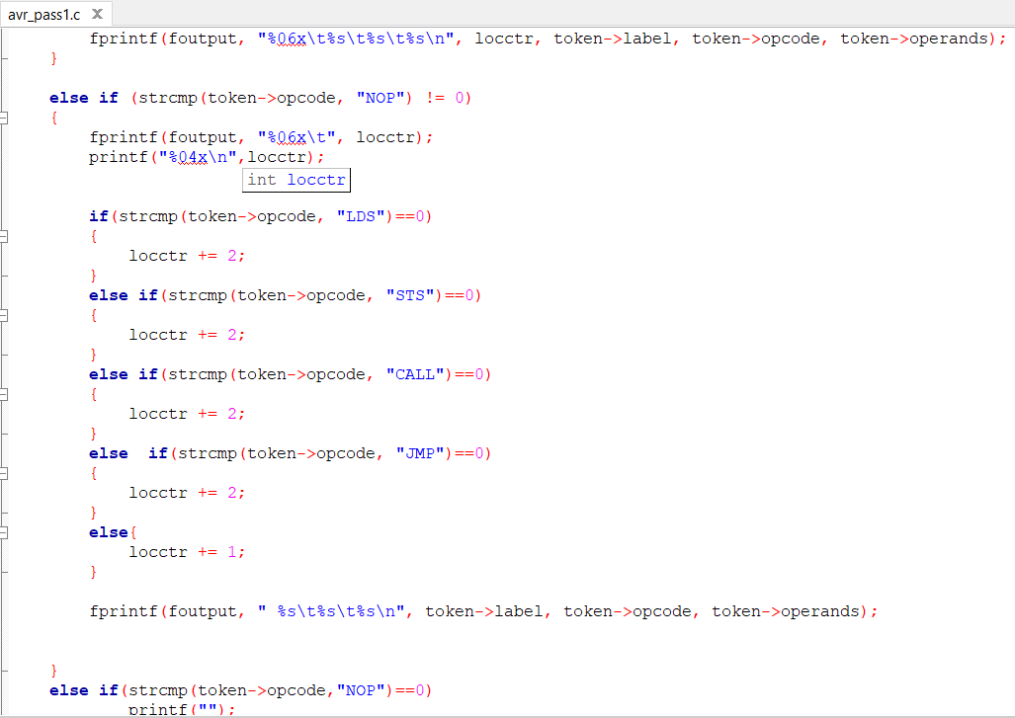

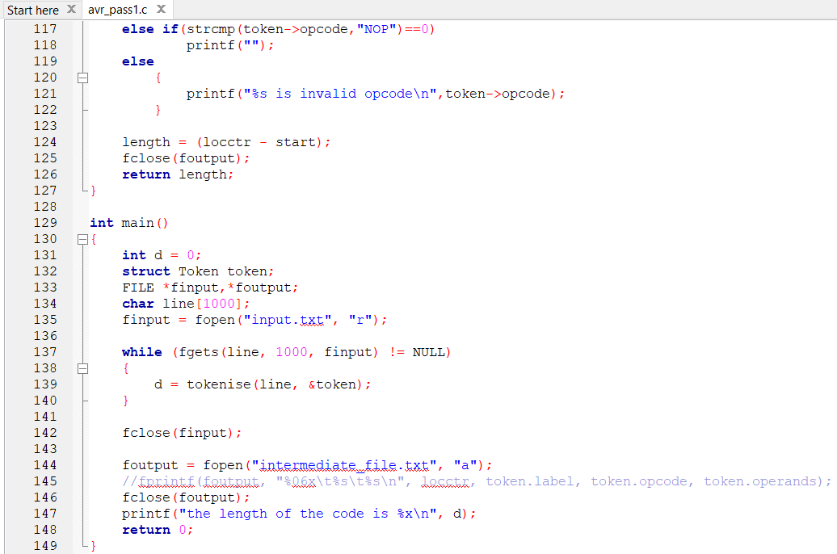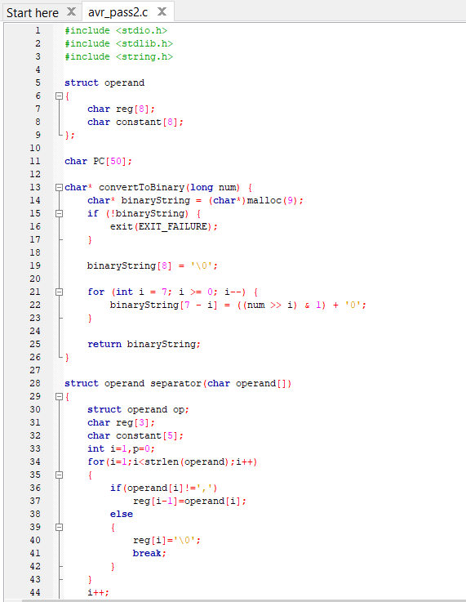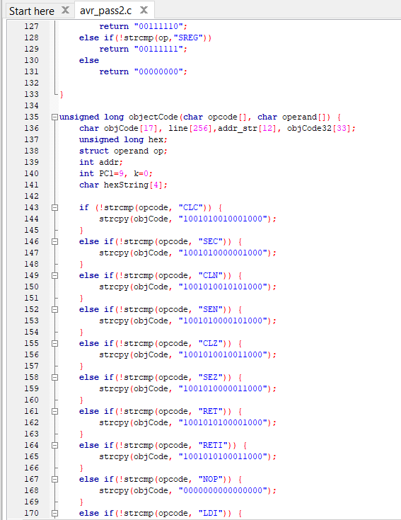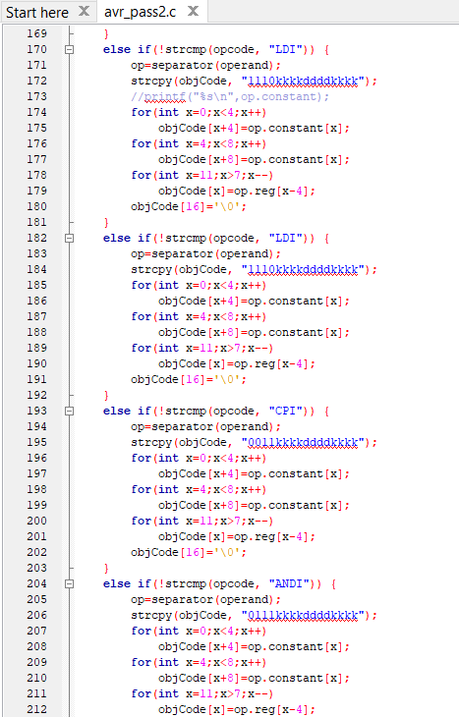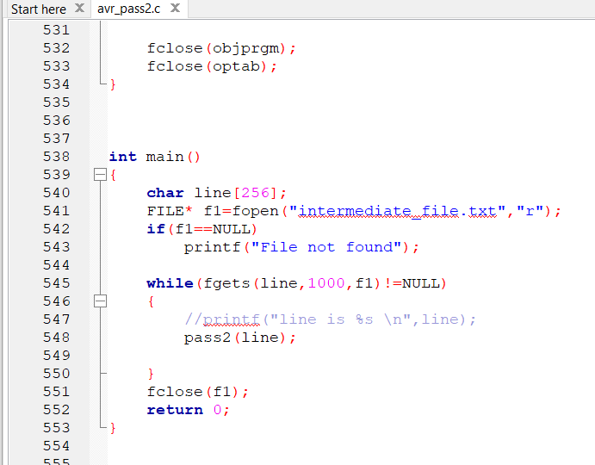

Pass 1:

Objective: In the first pass, the assembler scans through the entire source code to create a symbol table. It calculates the memory location (address) of each instruction and assigns symbolic addresses to labels.
Actions:
Identifies and stores labels along with their corresponding addresses.
Determines the memory locations of instructions and directives.
Generates an intermediate file containing the addresses and opcode mnemonics.

Pass 2:

Objective: In the second pass, the assembler generates the machine code or an intermediate code using the information gathered in the first pass. It resolves addresses, substitutes constants, and produces the final output.
Actions:
Reads the intermediate file generated in pass 1.
Resolves symbolic addresses using the symbol table.
Generates the final machine code or intermediate code.
Outputs the assembled program or creates an object file.
Overall:

Pass 1: Establishes the structure of the program, assigns addresses,
and creates a symbol table.
Pass 2: Produces the final machine code or intermediate code using the
information from pass 1.

Input And Output:

Input :
LDI R16,0X00
OUT DDRB,R16
LDI R16,255
OUT DDRC,R16
IN R20,PINB
LSR R20
BRCS ODD
LDI R17,0X00
OUT PORTC,R17
JMP LAST
ODD LDI R17,255
OUT PORTC,R17
LAST JMP LAST

SYMBOL TABLE:

ODD 00000b
LAST 00000d

INTERMEDIATE FILE:

000000 LDI R16,0X00
000001 OUT DDRB,R16
000002 LDI R16,255
000003 OUT DDRC,R16
000004 IN R20,PINB
000005 LSR R20
000006 BRCS ODD
000007 LDI R17,0X00
000008 OUT PORTC,R17
000009 JMP LAST
00000b ODD LDI R17,255
00000c OUT PORTC,R17
00000d LAST JMP LAST

OPCODE TABLE:

ADD 18
AND 40
COMP 28
DIV 24
J 3C
JEQ 30
JGT 34
JLT 38
JSUB 48
LDA 00
LDCH 50
LDL 08
LDX 04
MUL 20
OR 44
RD D8
RSUB 4C
STA 0C
STCH 54
STL 14
STX 10
SUB 1C
TD E0
TIX 2C
WD DC

OBJECT PROGRAM:
000000 e000 LDI R16,0X00
000001 bb07 OUT DDRB,R16
000002 ef0f LDI R16,255
000003 bb04 OUT DDRC,R16
000004 b346 IN R20,PINB
000005 9546 LSR R20
000006 f020 BRCS ODD
000007 e010 LDI R17,0X00
000008 bb15 OUT PORTC,R17
000009 940c000d JMP LAST
00000b ef1f ODD LDI R17,255
00000c bb15 OUT PORTC,R17
00000d 940c000d LAST JMP LAST

Conclusion:

In conclusion, the development of an AVR assembler for all instructions involves
the design and implementation of robust data structures and algorithms. The assembler comprises two passes, each serving distinct purposes. Pass1 involves tokenization, symbol table construction, and preliminary error checks. Pass2 focuses on generating object code, resolving addresses, and encoding instructions.

Data structures like Symbol Table and Opcode Table play crucial roles in facilitating
efficient symbol lookup and opcode retrieval. The token structure aids in representing and processing assembly instructions. Algorithms for pass1 and pass2 ensure accurate translation from assembly to machine code, with a special emphasis on error detection and handling.

The assembler's correctness and efficiency heavily depend on thorough testing,
verification, and optimization. Address calculation algorithms ensure proper
handling of jump and branch instructions. Documentation algorithms contribute to
creating comprehensive documentation for users and developers. The assembler is
designed to be compatible with various AVR microcontrollers, providing a versatile
tool for embedded systems programming.

In summary, the AVR assembler is a sophisticated tool that bridges the gap between
human-readable assembly code and machine-executable instructions, enabling the
seamless development of AVR-based applications.

